**1. Application Security Groups (ASG):**

ASG is logical grouping of vm using this we can setup frontend and backend communication

* **Purpose**: Simplifies the management of security for virtual machines (VMs) in Azure by logically grouping VMs.
* **Functionality**:
  + Acts as a container to group virtual machines by their roles (e.g., web servers, application servers, database servers).
  + Allows administrators to define security rules for a specific group rather than individual IP addresses or subnets.
* **Benefits**:
  + **Dynamic Scalability**: You can add or remove VMs from an ASG without modifying the NSG rules.
  + **Simplified Management**: Eliminates the need to manage specific IP addresses in security rules.
  + **Role-Based Security**: Enables applying security rules based on the application's role rather than infrastructure details.
* **Example**: Suppose you have a group of web servers in an ASG called WebServers. You can define an NSG rule to allow HTTP (port 80) and HTTPS (port 443) traffic only to this ASG, without specifying individual IP addresses.

**2. Network Security Groups (NSG):**

* **Purpose**: Controls inbound and outbound network traffic to and from Azure resources at the network level.
* **Functionality**:
  + Works by applying rules that specify source/destination, protocol, port, and priority.
  + Can be associated with **subnets** or individual **network interfaces** (NICs) of VMs.
* **Key Components**:
  + **Inbound Rules**: Define allowed or denied traffic coming into a resource.
  + **Outbound Rules**: Define allowed or denied traffic leaving a resource.
  + **Priority**: Rules are processed in order of priority (lower numbers take precedence).
  + **Default Rules**: Azure provides some default rules, such as allowing VNet traffic and denying internet access by default.
* **Benefits**:
  + **Granular Control**: Fine-tune access to resources.
  + **Cost-Effective**: A simpler and cheaper option compared to third-party firewalls for basic network security.
  + **Scalability**: Can secure entire subnets or individual VMs.
* **Example**: An NSG can allow traffic from ASG-WebServers to ASG-DatabaseServers over port 1433 (SQL Server traffic) and block all other traffic.

**Relationship Between ASG and NSG:**

* NSGs implement the security rules, while ASGs act as dynamic identifiers for resources (VMs) in those rules.
* You define an NSG rule using ASGs as source or destination, enabling a logical and flexible configuration for network security.

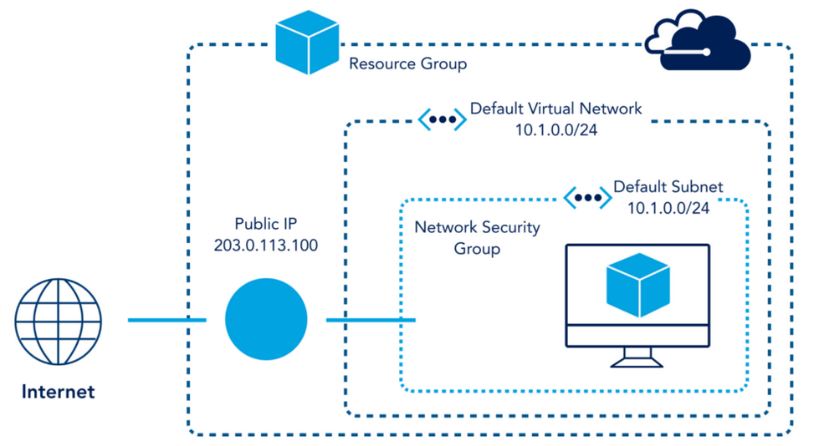

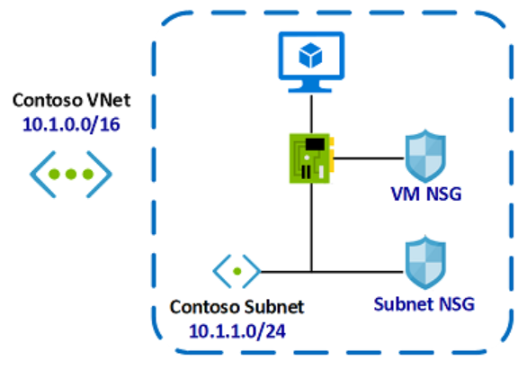

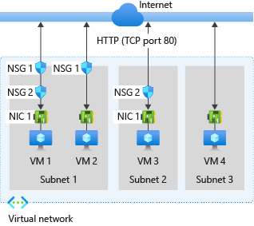

**ASG**

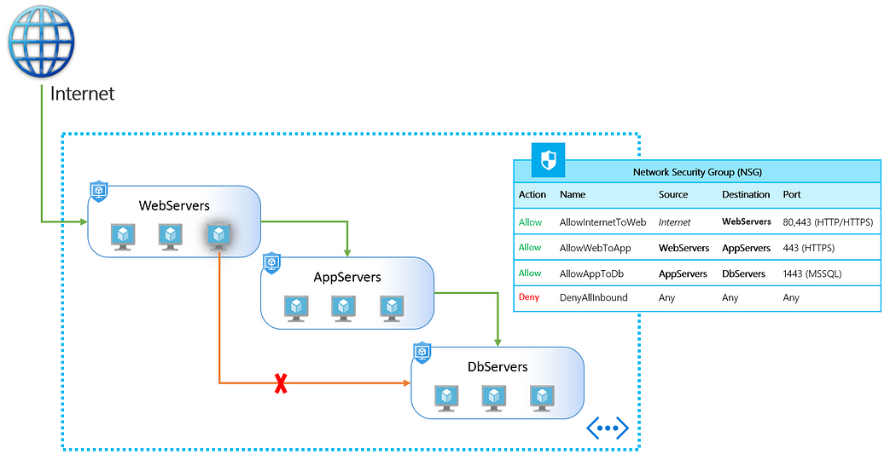

**Key Differences Between ASG and NSG:**

| **Feature** | **ASG** | **NSG** |
| --- | --- | --- |
| **Primary Role** | Logical grouping of VMs | Define traffic control rules |
| **Scope** | Application-specific | Network-wide or resource-specific |
| **Used In** | NSG rules as source/destination | Traffic management (inbound/outbound) |
| **Dynamic** | Yes, resources can join/leave dynamically | No, rules must be explicitly defined |

Step 1: Create a Virtual Network

1. Navigate to Azure Portal:

Go to Virtual Networks > Click + Create.

Name the VNet (e.g., MyVNet) and specify an address space (e.g., 10.0.0.0/16).

Add a subnet (e.g., MySubnet) with a range (e.g., 10.0.1.0/24).

Click Create.

Step 2: Create Virtual Machines

1. Create two VMs:

Go to Virtual Machines > Click + Create.

Use basic settings:

VM1: MyVM1 in the subnet MySubnet.

VM2: MyVM2 in the subnet MySubnet.

Use the same VNet (MyVNet).

2. Ensure both VMs are in the same resource group and VNet.

Step 3: Configure Network Security Groups (NSGs)

1. Create an NSG:

Go to Network Security Groups > Click + Create.

Name it MyNSG and attach it to MySubnet.

2. Add rules to the NSG:

Allow RDP: Add an inbound rule to allow port 3389 for RDP.

Allow HTTP: Add an inbound rule to allow port 80.

Block ICMP: Add a rule to deny ICMP (ping requests).

Step 4: Test NSG Rules

1. Connect to VM1 via RDP:

Verify RDP is allowed.

2. Test HTTP traffic:

Install a web server (e.g., IIS on Windows or Apache on Linux) on VM1.

Try accessing the web server from VM2.

3. Ping VM1 from VM2:

Open a command prompt on VM2 and try ping <VM1_IP>.

Confirm ICMP is blocked by the NSG.

Step 5: Create Application Security Groups (ASGs)

1. Create ASGs:

Go to Application Security Groups > Click + Create.

Create two ASGs:

WebServers (for VMs hosting web apps).

DatabaseServers (for VMs hosting databases).

2. Assign VMs to ASGs:

Attach VM1 to WebServers.

Attach VM2 to DatabaseServers.

3. Modify NSG Rules for ASGs:

In MyNSG, create a rule:

Allow HTTP traffic from WebServers to DatabaseServers.

Step 6: Test ASG Rules

1. Verify ASG-Based Communication:

Try accessing VM2 (simulate database access) from VM1 using HTTP traffic.

Confirm traffic flows only between allowed ASGs.

Jump Host:

A **jump host** (also known as a **jump server** or **bastion host**) in Azure is a virtual machine or managed service that acts as a gateway to access other resources in your network, such as virtual machines in private subnets. It is a secure entry point for administrators, reducing the attack surface by centralizing and controlling access.